# Chapter 2.7: Initial Class Diagram

Class Diagram is static diagram that represents the static view of an application. Class Diagram is not only used for visualizing, describing and documenting different aspects of a system but also for constructing executable code of the software application. Through the help of the NLA above I have designed the class diagram which is shown below:

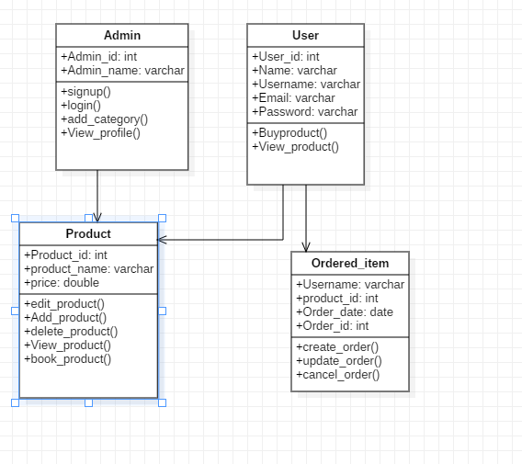

Figure 7: Initial Class Diagram for Nepal Handicraft Online Market

The following class diagram is prototype for the final class diagram that will be made. In the following class diagrams, I have made 4 classes which contains their respective attributes and functions. The classes are linked with one another with direct association. The following class diagram will help in designing the final class diagram.